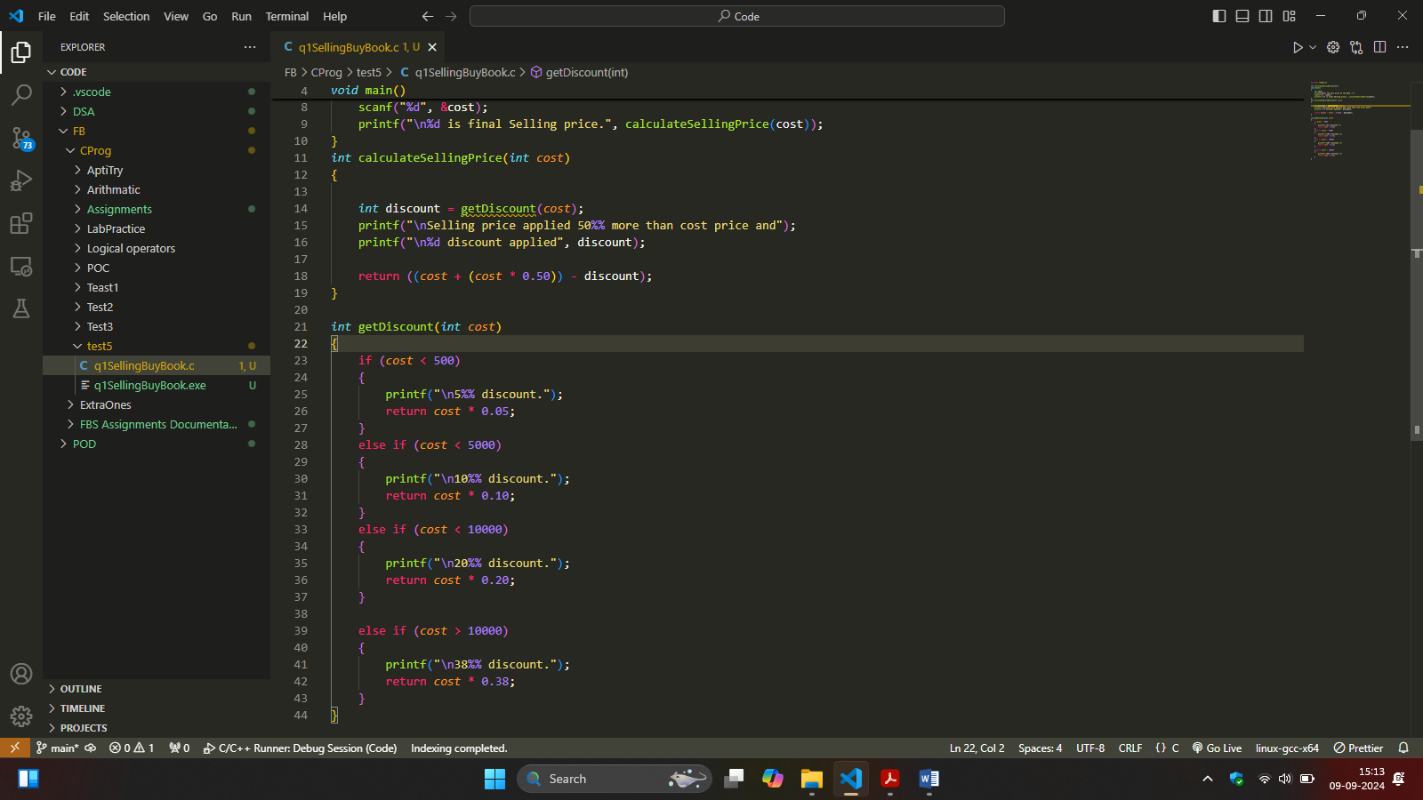

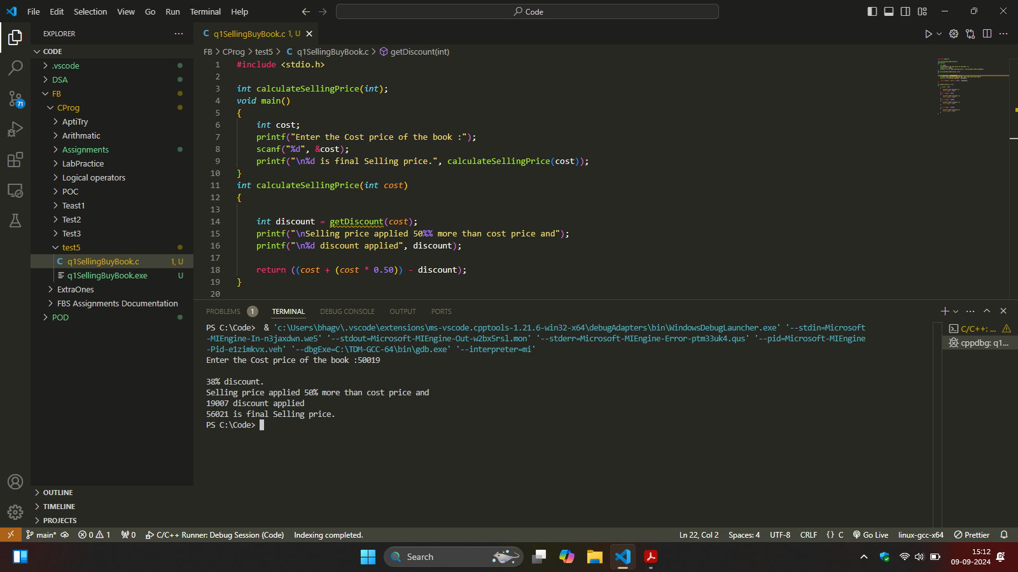

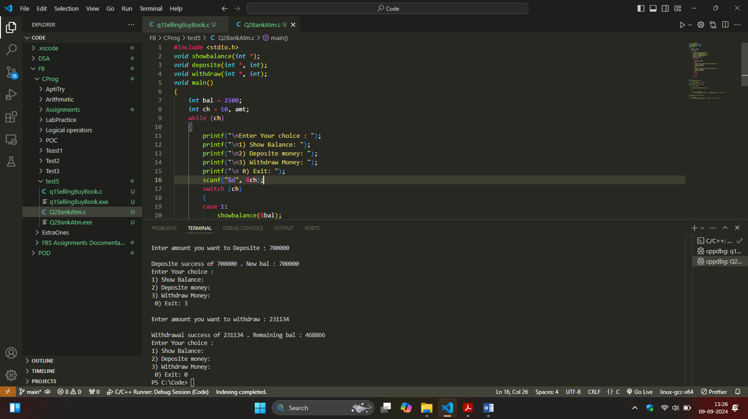

#include <stdio.h>

*void* showbalance(*int* \*);

*void* deposite(*int* \*, *int*);

*void* withdraw(*int* \*, *int*);

*void* main()

{

*int* bal = 2500;

*int* ch = 10, amt;

    while (ch)

    {

        printf("\nEnter Your choice : ");

        printf("\n1) Show Balance: ");

        printf("\n2) Deposite money: ");

        printf("\n3) Withdraw Money: ");

        printf("\n 0) Exit: ");

        scanf("%d", &ch);

        switch (ch)

        {

        case 1:

            showbalance(&bal);

            break;

        case 2:

            printf("\nEnter amount you want to Deposite : ");

            scanf("%d", &amt);

            deposite(&bal, amt);

            break;

        case 3:

            printf("\nEnter amount you want to withdraw : ");

            scanf("%d", &amt);

            withdraw(&bal, amt);

            break;

        case 0:

            return;

            break;

        default:

            break;

        }

    }

}

*void* showbalance(*int* \**ba*)

{

    printf("\nBalance: %d", \**ba*);

}

*void* withdraw(*int* \**ba*, *int* *amt*)

{

    if (\**ba* < 3000)

    {

        printf("\nLow balance broo!!!!");

    }

    else

    {

        \**ba* = \**ba* - *amt*;

        printf("\nWithdrawal success of %d . Remaining bal : %d", *amt*, \**ba*);

    }

}

*void* deposite(*int* \**ba*, *int* *amt*)

{

    \**ba* += *amt*;

    printf("\nDeposite success of %d . New bal : %d", *amt*, \**ba*);

}

Output : PS C:\Code> & 'c:\Users\bhagv\.vscode\...\ TDM-GCC-64\bin\gdb.exe' '--interpreter=mi'

Enter Your choice :

1) Show Balance:

2) Deposite money:

3) Withdraw Money:

0) Exit: 1

Balance: 2500

Enter Your choice :

1) Show Balance:

2) Deposite money:

3) Withdraw Money:

0) Exit: 2

Enter amount you want to Deposite : 2500

Deposite success of 2500 . New bal : 5000

Enter Your choice :

1) Show Balance:

2) Deposite money:

3) Withdraw Money:

0) Exit: 3

Enter amount you want to withdraw : 5000

Withdrawal success of 5000 . Remaining bal : 0

Enter Your choice :

1) Show Balance:

2) Deposite money:

3) Withdraw Money:

0) Exit: 3

Enter amount you want to withdraw : 500

Low balance broo!!!!

Enter Your choice :

1) Show Balance:

2) Deposite money:

3) Withdraw Money:

0) Exit: 1

Balance: 0

Enter Your choice :

1) Show Balance:

2) Deposite money:

3) Withdraw Money:

0) Exit: 2

Enter amount you want to Deposite : 700000

Deposite success of 700000 . New bal : 700000

Enter Your choice :

1) Show Balance:

2) Deposite money:

3) Withdraw Money:

0) Exit: 3

Enter amount you want to withdraw : 231134

Withdrawal success of 231134 . Remaining bal : 468866

Enter Your choice :

1) Show Balance:

2) Deposite money:

3) Withdraw Money:

0) Exit: 0

PS C:\Code>